The Influence of ICT Development on Cyber Terrorism Activities. Case Studies: Propaganda by Terrorist Groups Such as Al-Qaeda and ISIS

Theo Gerald Parluhutan Napitupulu
Universitas Brawijaya
Theogerald22@gmail.com

ABSTRACT
Currently, the development of ICT breaks down the boundaries of space and time between individuals. The development of ICT has a negative impact, one of which is the activity of cyber-terrorism which makes the scope of terrorism groups wider and more dangerous. Al-Qaeda and (ISIS) are examples of terrorism groups that make good use of ICT developments for the benefit of their respective groups. The current terrorist group not only wants to create mass destruction for western countries but also wants to create mass disruption. This paper seeks to explain the influence of ICT developments on terrorism activities, especially propaganda. To achieve this goal, the authors will use case studies of propaganda activities carried out through information and communication technology by Al-Qaeda and ISIS.

Keywords: ICT, Al-Qaeda, ISIS, Propaganda

- INTRODUCTION
Terrorism is a phenomenon that has become one of the main international agendas that is most discussed and debated, especially after 9/11 in the United States. President George W. Bush declared the war known as "war on terrorism" and turned into "war on terror" when President Bush gave a formal speech to Congress. Nowadays, widespread terrorism activity that previously occurred in the real world has spread to cyberspace. This phenomenon is influenced by the rapid and limitless development of ICT. The development of ICT breaks down the boundaries of space and time in which all individuals can connect with one another without being limited by geographical distance or local time. The development of ICT moves using an internet connection network system. ICT is something that is currently attached to the daily life of individuals. Although the development of ICT has positive impacts, negative impacts will always exist, one of which is crime or acts of terrorism through the internet (cyber-terrorism). This paper uses two case studies, namely the activities of cyber terrorism, namely the propaganda carried out by Al-Qaeda and ISIS.
- Propaganda by Al-Qaeda
Propaganda has become one of the main tools for Al-Qaeda to spread ideology and increase sympathy and jihadism for people, especially Muslims around the world or Umma. Al-Qaeda made itself a global representative of global Jihad so that propaganda and public communication played an important role for Al-Qaeda to spread ideology and shape public sympathy and opinion.. Al-Qaeda's propaganda increased significantly in the aftermath of the 9/11 attacks. The main purpose of the propaganda carried out by Al-Qaeda is to spread sentiment against the United States or Anti-Western towards the United States. Osama bin Laden, who is the center of thought of the ideology of Al-Qaeda, was influenced by Sayyid Qutb's writing (such as Milestones and In the Shade of the Quran). Qutb is an article containing anti-Western sentiment which gives the idea that western countries are the main enemy of Muslims and argues that western countries led by the United States are a manifestation of Satan (Huntington, 2004).
.Al-Qaeda uses posters, books and pamphlets, radio, television but due to the rapid development of ICT and the presence of the internet, Al-Qaeda's propaganda has entered a new level. In the aftermath of the 9/11 attacks, Al-Qaeda used video and audiotaped massages to praise and support acts of terrorism and threaten that greater violence would occur. Al-Qaeda also provides training materials for terrorists such as the Encylopedia of the Afghan Jihad, 2001 training videos, and several manuscripts such as In the Shadow of Lance and Inspire online magazine which are useful for explaining terrorist goals and spreading the understanding of Al-Qaeda and as a justification for the violence they commit (Rabasa et al., 2006)
- Propaganda by ISIS
ISIS is a terrorist group that takes advantage of the development of ICT in its propaganda activities. ISIS sees the media as an important tool for promoting itself and the ideology of their group. ISIS produces propaganda materials in the form of photos, videos and other writings published through ISIS's official media, namely the Al-Hayat Media Center, which was founded in 2014 (Gertz, 2014). In July 2014, ISIS created the digital magazine Dabiq, which came with 1-15 editions which was then followed by the digital magazine Rumiyah (Gambhir, 2016). This magazine is translated into 10 languages ​​namely English, Bahasa, Bosnian, French, Russian, Turkish, German, Kurdish, Pashto, and Uyghur. ISIS also uses social media such as Facebook, Twitter, Tumblr, Youtube and so on for the benefit of their group. Twitter is used to attract a larger crowd and audience by promoting ISIS in a more subtle way, namely using hashtags or memes to which a jihad component is added. More than 100,000 tweets were downloaded by ISIS when the invasion of Iraq took place (Farwell, 2014). Tumblr is a forum to tell the personal lives of ISIS fighters such as Diary of Muhajirah, Paladin of Jihad and Al-Muhajirat (Putri, 2019).
ISIS also often conducts live broadcasts on the internet such as the killing of Turkish and Jordan soldiers which aim to spread fear and psychologically affect their opponents and all people in the world (Akbar, 2017). Therefore, based on these two case studies, the research question of this paper is, how much influence does the development of ICT have on cyber-terrorism? In this paper, the author will explain the influence of ICT developments on cyber-terrorism activities. The author will attempt to analyze the research question based on two case studies, namely the propaganda carried out by Al-Qaeda and the Islamic State of Iraq and Syria (ISIS).
- LITERATURE REVIEW
This paper discusses the influence of ICT developments on existing terrorism or cyber-terrorism activities. Cyber-terrorism comes from two words, namely cyber and terrorism. UN Security Council Resolution 1566 of 2004 defines terrorism as: “criminal acts, including against civilians, committed with the intent to cause death or serious bodily injury, or taking of hostages, with the purpose to provoke a state of terror in the general public or in a group of persons or particular persons, intimidate a population or compel a government or an international organization to do or to abstain from doing any act ” (United Nations Security Council, 2004).
Nowadays, the development of ICT is increasingly fast where all human beings can connect to one another via the internet in a virtual world. Cyber, Cyberspace, or the virtual world is a phenomenon that arises as a result of the rapid development of ICT. The World Economic Forum states that "cyber refers to the interdependent network of information technology infrastructure, and includes technology" tools "such as the internet, telecommunications networks, computer systems, and embedded processors and controllers in critical industries" (World Economic Forum, 2012). Cyberspace is a virtual world formed from the merger between humans and technology which is influenced by developments in information and communication technology (Astuti, 2015). The development of ICT is like a double-edged knife, which means that the development of ICT is very useful for the development of mankind but at the same time threatens human life itself. The advancement of ICT has triggered the development of terrorism activities in cyberspace..
Cyber-terrorism is an activity or method used by a number of terrorist networks or groups (A.S & Fitriana, 2017). The term cyber-terrorism was first introduced in 1980 by Barry Collin. The definition of cyber-terrorism according to Collin is the transition of terrorism activities from the physical world to the virtual world (Collin, 1997). In cyber-terrorism activities, Cahyana Ahmad argues that terrorism basically occurs when a person or group of people carries out illegal activities that harm others through information technology. Infiltration into a protected computer system with the aim of stealing or destroying data or information is classified as cyber-terrorism activity (Ahmadjayadi, 2003). Cyber-terrorism can also be said to be the use of computers and the internet in terrorist activities (Kontselidze, 2015). Terrorist groups can take advantage of the development of ICT through cyberspace to carry out terrorist activities in the form of propaganda aimed at spreading their ideology, to attract sympathy for Muslims around the world, recruit new members, and much more.
- DISCUSSION
The development of ICTs took terrorist activity to a whole new level. Terrorist groups such as Al-Qaeda and ISIS use ICT developments to spread propaganda via the internet and social media. Jowett and O'Donnel define propaganda as “deliberate, systematic attempt to shape perceptions, manipulate cognitions, and divert behavior to achive a response that further the desired intent of the propagandist” (Jowett & O’Donnell, 2012). Bernays added that the use of propaganda can influence general public psychology or mass psychology (Bernays, 1928). It can work the same way in cyberspace that Al-Qaeda and ISIS do. The two terrorist groups take advantage of the development of ICT to carry out propaganda as an effort to form and attract sympathy for Muslims around the world (umma) and as a form of justification for the violence they commit.
In 2002 Bin Laden said that, “it is obvious that the media war in this century is one of the strongest methods; in fact, its ratio may reach 90% of the total preparation for the battles. " Another Al-Qaeda leader, Ayman al-Zawahiri in 2005 said that “more than half of this battle is taking place in the battle field of media. We are in a media battle in a race for hearts and minds of our umma. " (Awan, 2010). There are more than 4,000 Web sites that are used as platforms for waging jihad. As well as attracting sympathy and spreading their group's ideology, Al-Qaeda combines multimedia propaganda and ICT advances to create psychological warfare (Sauter, 2015; Weimann, 2004).
ISIS on the other hand has a different goal from Al-Qaeda in spreading its propaganda. While Al-Qaeda focuses on efforts and narratives to fight the West and considers them to be enemies of Muslims, ISIS is broadening their aims by creating Islamic Caliphate as their main goal and fighting against the West that gets in their way. Al-Qaeda prefers an approach to create terror in western countries and spread its propaganda carefully so as not to be detected. On the other hand, ISIS prioritizes openness to ideology for everyone who wants to shape their own thoughts with ISIS branding. It makes it easier for them in recruiting foreign fighters from western countries and encourages them to carry out their own attacks individually or lone wolf attackers (Arifin, 2017).
- ANALYSIS
Terrorism groups usually carry out their propaganda activities through online media. Youtube is a form of ICT development which has become one of the most frequently used online platforms for Al-Qaeda and ISIS because it is able to reach large public spaces. In 2019, One of Al-Qaeda's leaders, Ayman al-Zawahiri celebrated the 18th anniversary of the 9/11 attacks. Ayman al-Zawahiri is a fugitive from the United States who has yet to be arrested. The development of ICT allows one of the most wanted individuals in the world to make statements safely and confidentially and be seen by everyone in the world.

Image 1. Image from video of Ayman al-Zawahiri's statement celebrating the 18th anniversary of the 9/11 attacks
Source: NBC New York, 2019

Ayman al-Zawahiri tries to convince Muslims in the world to continue the jihad they are doing and tries to gather Al-Qaeda fighters against the West. ISIS also often downloads propaganda videos of executions on Youtube as part of their efforts to spread terror and gather individuals around the world who want to join ISIS.
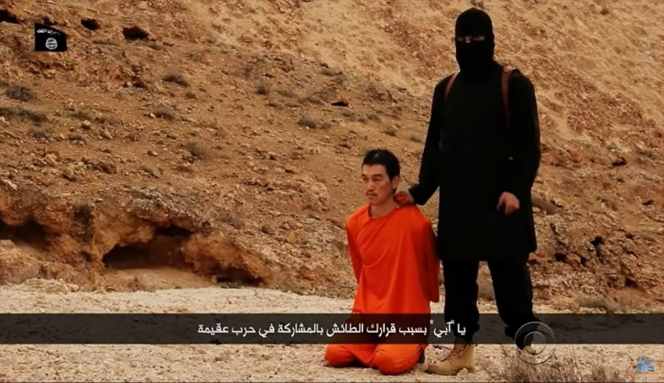

Image 2. Images from videos of ISIS members executing journalists from Japan
Source: CBC Evening News, 2015

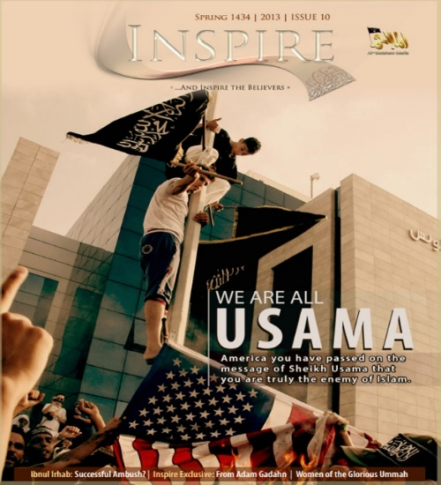
Another medium used for propaganda is online magazines. Al-Qaeda owns the Inspire magazine and ISIS has the Dabiq magazine, Inspire Magazine was first published in January 2010.

Image 3. Cover view of Al-Qaeda's Inspire magazine
Source: https://www.channel4.com/news/inside-the-al-qaeda-magazine

With eye-catching designs and images, the Inspire is characterized by a neat and seamless blend of ideologically driven material with pragmatic guidance and skills building content. This magazine focuses on inspiring followers to carry out individual jihad against the West, and its how-to-guide section of Open Sources Jihad (OSJ). OSJ covers a wide range of technical expertise from trainers in using weapons and making home bombs (Reed & Ingram, 2017) (Ingram, 2018)
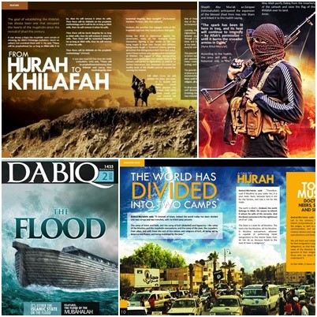

Image 4. The cover view of ISIS's Dabiq magazine
Source: https://cbap.cz/archiv/3423

ISIS has the Dabiq magazine which serves as the main communication tool containing life in the Islamic Caliphate. This magazine also serves as a justification tool for religion and political ideology (ISIS). This magazine is an ISIS propaganda tool so the contents of Dabiq magazine are not completely correct. Dabiq magazine consists of 15 issues that focus on the issues of tawhid (oneness of God), manhaj (methodology), hijrah (migration), jihad (struggle), and jama'ah (organization) (Ingram, 2018).

- CONCLUSION
From the two case studies, it can be concluded that the development of ICT greatly influences terrorist activities. The development of ICT has led to the emergence of platforms such as YouTube and websites that make it easier for terrorist groups to carry out their actions, especially propaganda. The propaganda carried out by Al-Qaeda and ISIS using ICT developments was able to reach a much larger community and individuals. The development of ICT has made terrorism activities, especially propaganda, become more massive and dangerous.
REFERENCES
A.S, A. B., & Fitriana, I. (2017). Cyberterrorism: Suatu Tantangan Komunikasi Asimetris bagi Ketahanan Nasional. InterKomunika. https://doi.org/10.33376/ik.v2i1.12
Ahmadjayadi, C. (2003). Dampak Teknologi Komunikasi Dan Informasi Terhadap Kegiatan Terorisme. Badan Pembinaan Hukum Nasional.
Akbar, Z. (2017). Why join ISIS? The Causes of Terrorism from the Muslim Youth Perspective [The University of Huddersfield]. http://eprints.hud.ac.uk/id/eprint/32612/1/FINAL THESIS - ZARA AKBAR.pdf
Arifin, N. A. (2017). The Evolution of ISIS In Indonesia With Regards to Its Social Media Strategy. Jurnal Ilmiah Hubungan Internasional. https://doi.org/10.26593/jihi.v13i2.2627.145-158
Astuti, S. A. (2015). Law Enforcement of Cyber Terorism in Indonesia. Rechtsidee. https://doi.org/10.21070/jihr.v2i2.82
Awan, A. (2010). The Virtual Jihad: An Increasingly Legitimate Form of Warfare. CTC Sentinel (Combatting Terrorism Center), 3(5), 10–13.
Bernays, E. (1928). Propaganda. H. Liveright.
Collin, B. (1997). Future of Cyberterrorism: The Physical and Virtual Worlds Converge. Crime and Justice International, 13(2), 15–18.
Farwell, J. P. (2014). The Media Strategy of ISIS. Survival. https://doi.org/10.1080/00396338.2014.985436
Gambhir, H. (2016). The Virtual Caliphate: ISIS’s Information Warfare. Institute for the Study of War. http://www.understandingwar.org/sites/default/files/ISW The Virtual Caliphate Gambhir 2016.pdf
Gertz, B. (2014). New Al Qaeda Group Produces Recruitment Material for Americans, Westerners. The Washington Free Beacon. https://freebeacon.com/national-security/new-al-qaeda-group-produces-recruitment-material-for-americans-westerners/
Huntington, S. P. (2004). Al-Qaeda: A Blueprint for International Terrorism in the Twenty-First Century? Defence Studies, 4(2), 229–255. https://doi.org/https://doi.org/10.1080/1470243042000325922
Ingram, H. J. (2018). Islamic State’s English-language Magazines, 2014-2017: Trends & Implications for CT-CVE Strategic Communications. Terrorism and Counter-Terrorism Studies. https://doi.org/10.19165/2018.1.03
Jowett, G., & O’Donnell, V. (2012). Propaganda & Persuasion (7th ed.). SAGE Publications, Inc. https://assets.thalia.media/doc/36/96/3696ccd9-1ed1-4344-be9c-d0055aa174a8.pdf
Kontselidze, A. (2015). Cyberterrorism -When Technology Became a Weapon. European Scientific Journal.
Putri, S. D. (2019). Cyber Terrorism: Strategi Propaganda dan Rekrutmen ISIS di Internet dan Dampaknya Bagi Indonesia Tahun 2014-2019. Journal of International Relations.
Rabasa, A., Chalk, P., Cragin, K., Daly, S., Gregg, H., Karasik, T., O’Brien, K., & Rosenau, W. (2006). Al-Qaeda’s Ideology and Propaganda. In Beyond al-Qaeda: Part 1, The Global Jihadist Movement. RAND Corporation. http://www.jstor.org/stable/10.7249/mg429af.10
Reed, A., & Ingram, H. (2017). Exploring the Role of Instructional Material in AQAP’s Inspire and ISIS’ Rumiyah. 1st European Counter Terrorism Centre (ECTC), EUROPOL, 1–17. https://icct.nl/app/uploads/2017/06/reeda_ingramh_instructionalmaterial.pdf
Sauter, M. (2015). Terrorism in Cyberspace: The Next Generation. Journal of Communication. https://doi.org/10.1111/jcom.12193
United Nations Security Council. (2004). Resolution 1566. https://www.un.org/ruleoflaw/files/n0454282.pdf
Weimann, G. (2004). www.terror.net - How Modern Terrorism Uses the Internet. USIP Special Report.
World Economic Forum. (2012). Risk and Responsibility in a Hyperconnected World Pathways to Global Cyber Resilience. http://www3.weforum.org/docs/WEF_IT_PathwaysToGlobalCyberResilience_Report_2012.pdf

